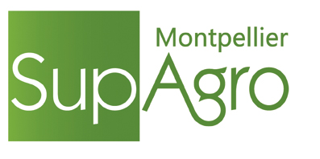
FRANCE

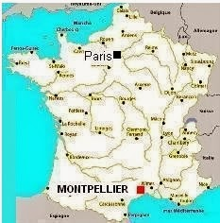

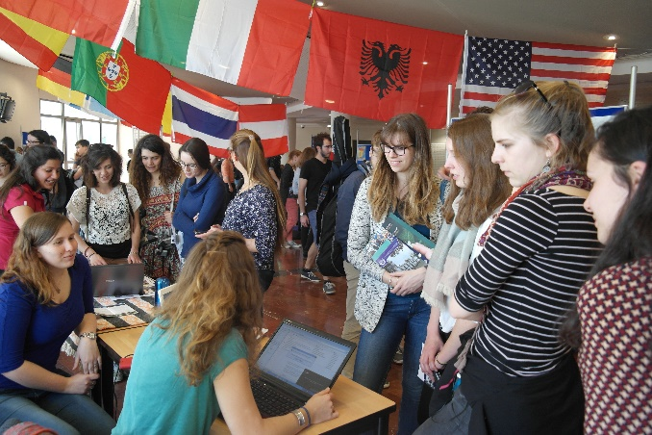
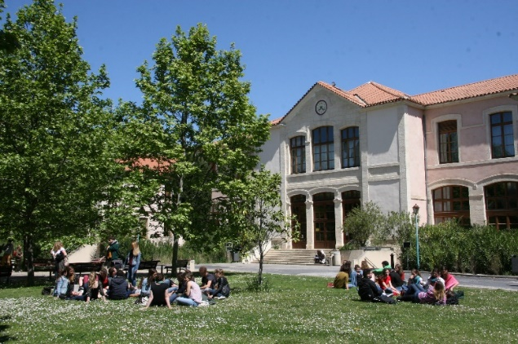

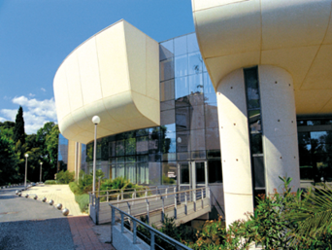
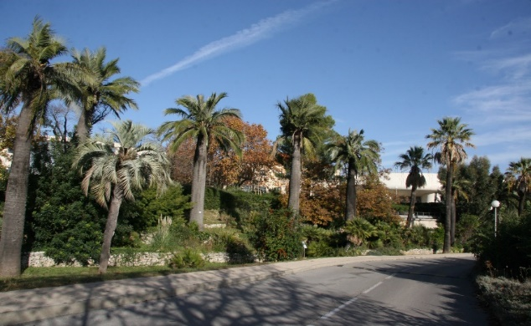
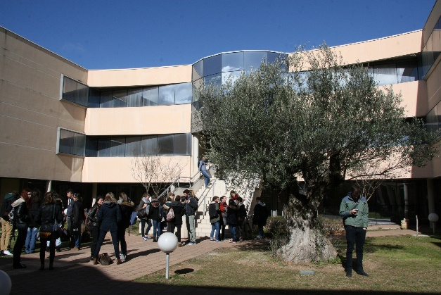
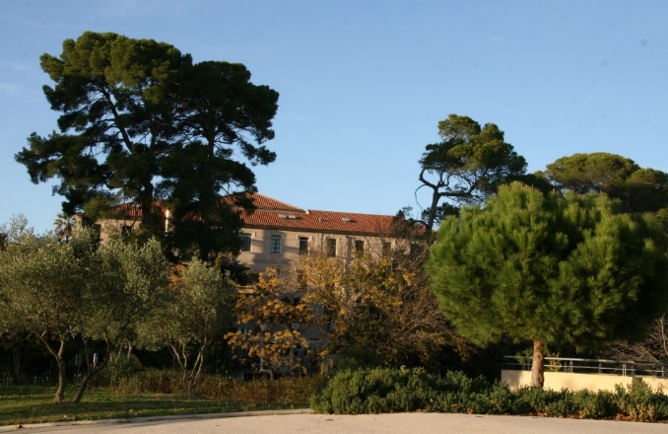
Montpellier Sup Agro is dedicated to education, from B.Sc. to PhD level, research, international scientific and technical cooperation in Agricultural Sciences, Agri-Food Science, Environment and Rural Management.

COME ON ACADEMIC EXCHANGE
MONTPELLIER SUPAGRO - France
ACADEMIC EXCHANGE 2017-2018

Academic Calendar

Year 1 MSc Level
Semester | Jul |  | Aug |  | Sept |  | Oct |  | Nov |  | Dec |  | Jan |  | Feb |  | Mar |  | Apr |  | May |  | Jun |  | Jul |  | Aug |  | Sept
Autumn
Spring

Year 2 MSc Level
Semester | Jul |  | Aug |  | Sept |  | Oct |  | Nov |  | Dec |  | Jan |  | Feb |  | Mar |  | Apr |  | May |  | Jun |  | Jul |  | Aug |  | Sept
Autumn
Spring

 | Elective Summer Courses |  | Intensive French Course |  | Autumn Semester |  | Spring Semester

Courses open to exchange students
Find attached the course offers for students in international mobility, for each mobility period:
Full year, Autumn semester or Spring semester.

Language of instruction
Courses are taught either in French or in English depending on the selected courses.

For more information, see course offers attached.

Language Courses

• French Language Courses
French Language courses are free of charge and organized as follows:
- Intensive courses: 3hrs /day, 2 weeks before the beginning of each semester and
- Regular courses: 2hrs /week, the whole year.

For more information see French Language Courses (www.supagro.fr/web/en/pages/?idl=19&page=1402).

• Other Language Courses
Students can also choose to attend free of charge English, Spanish or German courses: 1hr30 mins / week, subject to available places.

• French Summer Courses
We offer two summer programs in July and/or August for students who wish to improve their French language skills. Please note! Fees are due for Summer Courses.

For more information see:
- Agri-Culture Summer Course (www.supagro.fr/web/en/pages/?idl=19&page=1867)
- Language & Culture Summer Course (www.supagro.fr/web/en/pages/?idl=19&page=1825)

EU ECTS credits system
1 Semester = 30 ECTS credits.
Exchange students can validate all or part of these credits. The number of ECTS credits for each course is indicated on the Course Offers documents and on the application forms.

Welcome Events and Extra-Curricular Activities
The Students’ Association works with the International Academic Exchange Department to provide services and welcome activities for incoming international students:
- Pick-up service at the airport or train station
- Mentoring
- Informal arrival celebration and other integration activities…
Academic Exchange Students have the opportunity to participate in a wide range of sports and extra-curricular activities offered by Montpellier SupAgro and organized by the Student’s Association (www.supagro-alumni.fr/le-cercle-des-eleves - in French).
Students are helped with administrative tasks such as visas, insurance, housing, bank account...

Further information, see: It’s not all about studying! (www.supagro.fr/web/en/pages/?idl=19&page=1365).

Accommodation and Meals
Once accepted, students receive an application form for the booking of a room or a bedsit in one of Montpellier SupAgro's student residence halls, which are situated just across the road from La Gaillarde campus. Students are free to choose another type of accommodation in town.
Students can eat at the campus restaurant under the same conditions as the SupAgro students.

Lodging, Food, Transport, Visa & Miscellaneous (www.supagro.fr/web/en/pages/?idl=19&page=1360)
Mon guide, mon ami fidèle,(www.supagro.fr/web/UserFiles/File/02-formations/02-vie-etudiante/guide-mon-ami-version-2015.pdf) a guide written by and for students!
The Practical Guide for International Students in Languedoc Roussillon (https://languedoc-roussillon-universites.fr/images/Accueil-international/PDF/Guide-EI-2016-GB.pdf)

Application Requirements

• Bilateral Exchange Programs
International students are admitted through bilateral or multilateral exchange programs such as Erasmus +, Brafagri, Arfagri, Mexfitec, EULALinks, and bilateral MOU.

• Academic Level
Students should show official evidence that they have completed 6 semesters of graduate studies before the beginning of their academic exchange. Good academic results and the required prerequisites will be taken into account, especially for Autumn Semester Courses and long-term internships.

• Language Level
Students must have a B1/B2 level in French and/or in English, depending on the selected courses. For more information, please contact us.
No language proficiency is asked for an internship.

• Application
Students should be nominated by their home university ONLINE. Each nominated student will receive an email with his(her) login and password for the completion of his (her) application form ONLINE.

Deadline for application | Full Year or Autumn Semester | April 30th
 | Spring Semester | October 31th

Contacts at the International Relations Department

European Union, North America and Asia |  | Latin America
Ms. Maija Miikkola  maija.miikkola@supagro.fr  +33 (0)4 99 61 23 27 |  | Ms. Claudia Medina  claudia.medina@supagro.fr  +33 (0)4 99 61 27 29

MONTPELLIER SUPAGRO 2017-2018:
Track* Offers for Incoming International Mobility
FULL YEAR

* One Track corresponds to one line on the chart below (number of ECTS under brackets)
More information about each course on : https://www.supagro.fr/web/en/pages/?idl=19&page=1374
(Click on Courses open to exchange students – Open Full Year Mobility.pdf and click on a Track to get more information)
To find out how to choose a Track and language courses, see the explanations on the next page

Language
courses
Training in Research Unit
(12,5)

Training in Research Unit
(12,5)

Training in Research Unit
(12,5)
Training in Research Unit
(12,5)

Training in Research Unit
(12,5)

Training in Research Unit
(12,5)

Training in Research Unit
(12,5)

French
English
English and French
Teaching
Language
MSc 1 Level
Plant Sciences ** (21)
Internship (7)
Agroecology ** (21)
Internship (7)
Sustainable Development Policies and Strategies ** (21)
Internship (7)
Agri-Food (21)
Internship (7)
Sept
Oct
Nov
Dec
Jan
Feb
Mar
Apr
May
June
Jul
Aug
MSc 2 Level
Sept
Jul
Aug
Autumn Semester 2017 Spring Semester 2018

Paying French Summer Courses Language & Culture
Agri-& Culture

Free of Charge French Intensive Lessons + Weekly Lessons (1 + 2 + 1)
English, German, Spanish or Portuguese Courses (2 + 1)
Internship (20)
Coordination of Projects in Environmental Education and Sustainable Development (40) - Florac Campus
BSc Level
Internship (20)
Agricultural Management of Rural Natural Areas (40) - Florac Campus
** See “mixed courses” next page
Data Manager for Environmental Projects ** (21)
Internship (7)
Training in Research Unit
(12,5)

Training in Research Unit
(12,5)

Internship (7)
Agricultural and Food Systems in Southern Countries (21)
Training in Research Unit
(12,5)
Training in Research Unit
(12,5)
Training in Research Unit
(12,5)

Internship (7,5)
Water and Agriculture (52,5)
Internship (7,5)
Water and Society (52,5)
Internship (30)
Internship (30)
Agromanager (30)
Agri-Food and Agro-Industry (30)
Internship (30)
Plant Breeding, Mediterranean and Tropical Crops Engineering (30)
Internship (30)
Chemistry and Bio-Processes for Sustainable Developm. (30)
Internship (30)
Internship (30)
Livestock Farming System (30)
Sustainable Crop Production (30)
Internship (30)
Plant Protection and Environment (30) – Montpellier/Rennes/Paris
Internship (30)
Internship (30)
Data science for Agronomy and Agri-Food (30) - Rennes/Montpellier

Territories and Resources: Public Policies and Actors (30)
Internship (30)
Agro-Technologies of Information and Communication (30) – Montpellier/Bordeaux
Internship (30)
Water, Cultivated Areas and Environment Management (30)
Markets, Organization, Food Quality, Services in the Southern Agriculture (30)
Agri-Food Industry in the South (30)
Internship (30)
Internship (30)

Internship (25)
Internship (30)
Internship (30)
Resources and Agricultural Systems Development (30)
Water and Agriculture (35)
Water and Society (35)
Internship (25)
Economics of agricultural development, environment and food (30)
How to Choose from the Full Year Track Offers?

Foreign Languages

- In July and/or August, paying French Summer Courses are offered for non-French speaking students.
- Throughout the year Montpellier SupAgro offers free of charge Language Courses:

French | For students attending Tracks at M.Sc. 1 or M.Sc. 2 level | Intensive Courses:  30 hrs (3 hrs/day)  Regular Courses:  2hrs/week throughout the semester | Minimum admission level : B1 | 1 ECTS  +  2 ECTS  1st semester  +  1 ECTS  2d semester
English  Spanish  Portuguese  German | For students attending Tracks at M.Sc. 1 level | 1hr30mins/week throughout the semester | Admission level :  English: B1 to C1  Spanish / German : A0 to C1  Portuguese : A0 | 2 ECTS  1st semester  +  1 ECTS  2d semester

Obs:
- Depending on their level in English, English courses are recommended for students who wish to attend classes taught in English during the second semester.
- English courses are included in the 2 Tracks at B.Sc. level and in 3 Tracks at M.Sc. 2 level : “Agri-Food and Agro-Industry”, “Agromanager” and “Plant Breeding, Mediterranean and Tropical Crops Engineering”

Tracks and Teaching Units

A Track corresponds to one line on the Track offers chart.
Each Track is made up of several Teaching Units (UE) (see details of each Track by clicking on the corresponding link on the Track offers schema).
Each Track delivers 30 ECTS per semester.

- First possibility: Full course
Students must choose one of the Tracks depending on their academic level.
Students can attend a Track at M.Sc 1 or 2 level if they have officially validated at least 6 semesters of study (120 ECTS).
It is compulsory to attend all the Teaching Units of the chosen Track.

- Second possibility: Mixed course
4 of M.Sc.1 level Tracks can be combined: “Agroecology”, “Data Manager”, “Plant Sciences” and “Sustainable Development Policies and Strategies” (marked ** on the Track offers chart).
Each Track is made up of 3 1 month-Teaching Units.
Students should choose 1 Teaching Unit (UE) per period from the Teaching Units offered during the period.
Period 1 : | Period 2: | Period 3:
UE1 - Discover Agroecology | UE2 - Agroecology Principal Concepts | UE3 - The Agroecological Transition
UE1 - Collecting Environmental Data | UE2 - Environmental Data Processing and Analysis | UE3 - Mobile and Web Management of Environmental Data
UE1 - Public Policies, Behaviours and Sustainable Development | UE2 - Life Cycle Analysis and Sustainable Consumption | UE3 - Sustainable Development Initiatives
UE1 - Designing New Crops for the Future | UE2 - Training in AGROPOLIS Research Community | UE3 - Evolutionary applications in agriculture : Evolutionary Concepts for the Management of Agro-Ecosystems

Training in a Research Unit and Internship

Students that want to improve their level in French before the Spring Semester courses can attend a Training in a Research Unit during the Autumn Semester. They will be offered a scientific project in a laboratory on the campus within a French-speaking environment.

During the second part of the Tracks, students have to do an Internship in a laboratory or company.
Students have to find their internship. They will be guided and supported in their search.

For more information about laboratory internship, consult the list of Joint Research Units (UMR) or consult the UMR websites (www.supagro.fr/web/en/pages/?idl=19&page=1389).

MONTPELLIER SUPAGRO 2017-2018:
Track* Offers for incoming international mobility
AUTUMN SEMESTER

* One Track corresponds to one line on the chart below (number of ECTS under brackets)
More information about each course on : https://www.supagro.fr/web/en/pages/?idl=19&page=1374
(Click on Courses open to exchange students – Open Autumn Semester Mobility.pdf and click on a Track to get more information)
To find out how to choose a Track and language courses, see the explanations on the next page

Autumn Semester 2017 Spring Semester 2018

Language
courses
French
English
English and French
Teaching
Language
Sept
Oct
Nov
Dec
Jan
Feb
Mar
Apr
May
June
Jul
Aug
Sept
Jul
Aug

Paying French Summer Courses Language & Culture
Agri-& Culture

Free of Charge French Intensive Lessons + Weekly Lessons (1 + 2)
English, German, Spanish or Portuguese Courses (2)
Water and Agriculture (30)
MSc 1 Level
Water and Society (30)
MSc 2 Level
Agri-Food and Agro-Industry (30)
Agromanager (30)
Plant Breeding, Mediterranean and Tropical Crops Engineering (30)
Chemistry and Bio-Processes for Sustainable Development (30)
Livestock Farming System (30)
Plant Protection and Environment (30) – Montpellier/Rennes/Paris
Sustainable Crop Production (30)
Territories and Resources: Public Policies and Actors (30)
Data science for Agronomy and Agri-Food (30) - Rennes/Montpellier

Agro-Technologies of Information and Communication (30) – Montpellier/Bordeaux
Water, Cultivated Areas and Environment Management (30)
Agri-Food Industry in the South (30)
Markets, Organization, Food Quality, Services in the Southern Agricult. (30)
Resources and Agricultural Systems Development (30)
Water and Agriculture (30)
Water and Society (30)

Economics of agricultural development, environment and food (30)
MSc 2 Level
How to Choose from the Autumn Semester Track Offers?

Foreign Languages

- In July and/or August, paying French Summer Courses are offered for non-French speaking students.
- Throughout the year Montpellier SupAgro offers free of charge Language Courses:

French | For students attending Tracks at M.Sc. 1 or M.Sc. 2 level | Intensive Courses:  30 hrs (3 hrs/day)  Regular Courses:  2hrs/week throughout the semester | Minimum admission level : B1 | 1 ECTS  +  2 ECTS
English  Spanish  Portuguese  German | For students attending Tracks at M.Sc. 1 level | 1hr30mins/week throughout the semester | Admission level :  English: B1 to C1  Spanish / German : A0 to C1  Portuguese : A0 | 2 ECTS

Depending on their level in English, English courses are recommended for students who wish to attend classes taught in English.

Tracks and Teaching Units

A Track corresponds to one line on the Track offers chart.
Each Track is made up of several Teaching Units (UE) (see details of each Track by clicking on the corresponding link on the Track offers schema).
Each Track delivers 30 ECTS per semester.

Students must choose one of the Tracks depending on their academic level.
Students can attend a Track at M.Sc 1 or M.Sc. 2 level if they have officially validated at least 6 semesters of study (120 ECTS).
It is compulsory to attend all the Teaching Units of the chosen Track.

MONTPELLIER SUPAGRO 2017-2018:
Track* Offers for incoming international mobility
SPRING SEMESTER

* One Track corresponds to one line on the chart below (number of ECTS under brackets)

More information about each course on : https://www.supagro.fr/web/en/pages/?idl=19&page=1374
(Click on Courses open to exchange students – Open Spring Semester Mobility.pdf and click on a Track to get more information)
To find out how to choose a Track and language courses, see the explanations on the next page

Autumn Semester 2017 Spring Semester 2018
Sept
Aug
Jul
June
May
Apr
Mar
Feb
Jan
Dec
Nov
Oct
Sept
Language
courses
Free of Charge French Intensive
+ Weekly Lessons (1 + 1)
English, German, Spanish or Portuguese Courses (1)

Internship (7)
Plant Sciences ** (21)
MSc 1 Level
Internship (7)
Agroecology ** (21)
** See “mixed tracks” next page
Internship (7)
Data Manager for Environmental Projects ** (21)
Internship (7)
French
Sustainable Development Policies and Strategies ** (21)
Agri-Food (21)
Teaching
Language
English and French
English
Internship (7)
Internship (7)
Agricultural and Food Systems in Southern Countries (21)
Internship (7,5)
Water and Society (22,5)
Water and Agriculture (22,5)
Internship (7,5)
MSc 2 Level
Internship (25)
Water and Agriculture (5)
Internship (25)
Water and Society (5)

How to Choose from the Spring Semester Track Offers?

Foreign Languages

Throughout the year Montpellier SupAgro offers free of charge Language Courses:

French | For students attending Tracks at M.Sc. 1 or M.Sc. 2 level | Intensive Courses:  30 hrs (3 hrs/day)  Regular Courses:  2hrs/week throughout the semester | Minimum admission level : B1 | 1 ECTS  +  1 ECTS
English  Spanish  Portuguese  German | For students attending Tracks at M.Sc. 1 level | 1hr30mins/week throughout the semester | Admission level :  English: B1 to C1  Spanish / German : A0 to C1  Portuguese : A0 | 1 ECTS

Tracks and Teaching Units

A Track corresponds to one line on the Track offers chart.
Each Track is made up of several Teaching Units (UE) (see details of each Track by clicking on the corresponding link on the Track offers schema).
Each Track delivers 30 ECTS per semester.

- First possibility: Full course
Students must choose one of the Tracks depending on their academic level.
Students can attend a Track at M.Sc 1 or M.Sc. 2 level if they have officially validated at least 6 semesters of study (120 ECTS).
It is compulsory to attend all the Teaching Units of the chosen Track.

- Second possibility: Mixed course
4 of M.Sc.1 level Tracks can be combined: “Agroecology”, “Data Manager”, “Plant Sciences” and “Sustainable Development Policies and Strategies” (marked ** on the Track offers chart).
Each Track is made up of 3 of 1 month-Teaching Units
Students should choose 1 Teaching Unit (UE) per period from the Teaching Units offered during the period.

Period 1 : | Period 2: | Period 3:
UE1 - Discover Agroecology | UE2 - Agroecology Principal Concepts | UE3 - The Agroecological Transition
UE1 - Collecting Environmental Data | UE2 - Environmental Data Processing and Analysis | UE3 - Mobile and Web Management of Environmental Data
UE1 - Public Policies, Behaviours and Sustainable Development | UE2 - Life Cycle Analysis and Sustainable Consumption | UE3 - Sustainable Development Initiatives
UE1 - Designing New Crops for the Future | UE2 - Training in AGROPOLIS Research Community | UE3 - Evolutionary applications in agriculture : Evolutionary Concepts for the Management of Agro-Ecosystems

Internship

At the end of the Tracks, students have to do an Internship in a laboratory or a company.
Students have to find their internship. They will be guided and supported in their search.

For more information about laboratory internship, consult the list of Joint Research Units (UMR) below or consult the UMR websites (www.supagro.fr/web/en/pages/?idl=19&page=1389).

Montpellier SupAgro
Joint Research Units (UMR)
Contacts for Students Internships

BE Department – Biology and Ecology

UMR AGAP – Genetic Improvement & Adaptation of Mediterranean and Tropical Plants
The AGAP joint research unit endeavors to create the most suitable planting material for farming systems involving the main 20 tropical and Mediterranean species.
Information : http://umr-agap.cirad.fr/en
Members : Cirad, Inra, Montpellier SupAgro
Contact : dominique.this@supagro.inra.fr
Internship offers : http://www.cirad.fr/emplois-stages/stages

UMR BGPI – Biology and Genetics of Plant/Parasite Interactions for Integrated Protection
The BGPI joint research unit aims at studying plant diseases with the goal of proposing rational control methods. The researchers of BGPI unit work on viruses, bacteria and fungi (including quarantine organisms) that are pathogenic to temperate and tropical plants. Population dynamics of emerging diseases, mechanisms of pathogenicity and plant resistance are the main investigated domains. Knowledge transfer for quarantine management of genetics resources is also a strong component of our activities.
Information: http://umr-bgpi.cirad.fr/
Members : Inra, Cirad, Montpellier SupAgro
Contact: claire.neema@supagro.inra.fr

UMR BPMP – Biochemistry and Molecular Physiology of Plants
The B&PMP joint research unit is defined as an Integrative Biology research department, focused on the mechanisms of plant responses and adaptation to variable abiotic environmental conditions.
Information: http://www1.montpellier.inra.fr/ibip/bpmp/english/index.htm
Members : Inra, CNRS, UM, Montpellier SupAgro
Contact: pierre.berthomieu@supagro.fr
Internship offers : http://www1.montpellier.inra.fr/ibip/bpmp/emplois.htm

UMR CBGP - Centre for Biology and Management of Populations
The CBGP joint research unit aims to understand the mechanisms that govern populations of organisms that are important to agriculture, forests, human health and biodiversity conservation. Its studies concern biological models (arthropods, nematodes and rodents), and follow six lines of research: origin and characterization of biodiversity; adaptation of plant eaters, their natural enemies and symbionts; ecology and evolution of zoonoses; biology, ecology and evolution of invasive species; statistical and evolutionary population genomics; and high-throughput molecular and bioinformatics techniques
Informations : www6.montpellier.inra.fr/cbgp
Members : Cirad, Inra, IRD, Montpellier SupAgro
Contact: marie-stephane.tixier@supagro.fr - serge.kreiter@supagro.fr
Internship offers : http://www6.montpellier.inra.fr/cbgp/Informations-pratiques/Offres-stages-theses-post-doc

UMR LEPSE – Ecophysiology Laboratory of Plants under Environmental Stress
The LEPSE joint research unit produces methods and knowledge to help maximizing crop production with less input, essentially water. This objective was initially assigned in the context of the necessity to limit water use by agriculture. Ongoing climate change, with global temperature elevation, increased probability of heat waves and drought episodes have led us to widen our domain of research.
Information: http://www6.montpellier.inra.fr/lepse
Members : Inra, Montpellier SupAgro
Contact: anne.pellegrino@supagro.fr
Internship offers : http://www6.montpellier.inra.fr/lepse/Utile/Offres-d-emploi-Stages

USC CEFE – Centre for Functional and Evolution Ecology (CEFE)
The CEFE is currently the largest French research center in Ecology. Its mission is to perform independent, fundamental scientific research on the dynamics of biodiversity, planetary environmental change, and sustainable development. The CEFE works at a great variety of field sites around the world, but developed particular expertise in Mediterranean and tropical ecosystems. One of its main objectives is to develop scenarios on the evolution of biological systems, as well as strategies for their conservation and their restoration.
Information: http://www.cefe.cnrs.fr/fr/
Members : UM, CNRS, UM 3, EPHE, Montpellier SupAgro
Contact: elena.kazakou@supagro.fr
Internship offers : http://www.cefe.cnrs.fr/fr/emploi-stage-2/offres-de-stages

MPRS Department - Soils, Water, Crops and Livestock Systems Department

UMR Eco&Sols – Functional Ecology & Biogeochemistry of Soils
The aim of the Eco&Sols joint research unit is to use ecological engineering to propose scientifically-based practices to maintain and improve the agricultural and environmental functions of agro-ecosystems. The research undertaken by Eco&Sols seeks to describe and understand the ecological processes of primary production and the regulation of the carbon and nutrient fluxes in the agro-systems.
Information: http://www6.montpellier.inra.fr/ecosols_eng/Research
Members : Inra, Cirad, IRD, Montpellier SupAgro
Contact: edith.lecadre@supagro.fr – claire.marsden@supagro.fr

UMR LISAH - Laboratory for the Study of Interactions between Soil, Agro-Systems and Water Systems
The LISAH joint research unit focuses its work on hydrology, the transfer of contaminants and erosion of highly developed and cultivated soils. It also studies the spatial proprieties of these areas, and their evolution. These studies aim at analyzing the issues of water and soils in cultivated areas.
Information: https://www.umr-lisah.fr/
Members : Inra, IRD, Montpellier SupAgro
Contact: stephane.follain@supagro.fr - francois.colin@supagro.fr – armand.crabit@supagro.fr

UMR LSTM – Tropical and Mediterranean Symbioses Laboratory (LSTM)
The LSTM joint research unit studies microbiology and biology of plants, based on a multidisciplinary and integrative approach. It aims at understanding the molecular mechanism influencing the establishing of symbioses, as well as their role in ecosystematic services. It also studies the biodiversity of symbiotic microorganisms.
Information: http://umr-lstm.cirad.fr/l-unite
Members : UM, Cirad, IRD, Montpellier SupAgro
Contact: brigitte.brunel@supagro.inra.fr
Internship offers : http://umr-lstm.cirad.fr/offres-d-emploi-et-propositions-de-stages

UMR SELMET – Livestock Systems in Tropical and Sub-Tropical Regions
The SELMET joint research unit works on animal production agro-ecosystems in warm climates, in normal and harsh conditions. The extreme conditions under which some of these systems function challenge the limits of ecological intensification.
Information: http://umr-selmet.cirad.fr/en
Members : Inra, Cirad, Montpellier SupAgro
Contact: nathalie.agbagla@supagro.fr - charles-henri.moulin@supagro.inra.fr

UMR SYSTEM - Operation and Behavior of Tropical and Mediterranean Crop Systems
The SYSTEM joint research unit produces knowledge and tools to assess and design cropping systems combining economic efficiency and the production of environmental services. In Mediterranean and tropical areas, it explores the hypothesis whereby the biological diversity of species cultivated in the same place fosters ecological intensification.
Information: http://umr-system.cirad.fr/
Members : Cirad, Inra, Montpellier SupAgro, Ciheam-IAM
Contact: aurelie.metay@supagro.fr

SABP Department - Department of Sciences for Agro-Bio-Processes

UMR G-EAU - Water Management, Actors, Uses
The G-EAU joint research unit conducts researches on trajectory of hydrosystems and their regulation; it contributes to the conception and evaluation of facilities to develop innovating policies regarding to the management of water.
Information: http://www.g-eau.net/
Members : IRSTEA, Cirad, IRD, AgroParisTech, CIHEAM-IAMM, Montpellier SupAgro
Contact: gilles.belaud@supagro.fr
Internship offers : http://www.g-eau.net/index.php/recrutement/stages

UMR IATE – Agro-Polymer Engineering and Emerging Technologies
The IATE joint research unit generates knowledge regarding the structural-functional properties of plant-based products upon transformation to food, biomaterials, biomolecules and bioenergy.
Information: http://umr-iate.cirad.fr/
Members : Inra, Cirad, UM, Montpellier SupAgro
Contact: paul.menut@supagro.inra.fr

UMR ITAP – Information and Technology for Agro-Processes
The ITAP joint unit research develops and implements evaluation tools to measure the social and environmental impact of agricultural processes. It is mostly based on the analysis of life cycle and aims at ameliorating and developing ecotechnologies, in order to create long-lasting agricultural production.
Information: http://itap.irstea.fr/
Members : IRSTEA, Montpellier SupAgro
Contact: carole.sinfort@supagro.fr
Internship offers : https://itap.irstea.fr/?page_id=59

UMR MISTEA – Mathematic, Computing & Statistic for Environment and Agronomy
The activities of the MISTEA joint research unit concern the development of mathematical, statistical and computer science methods dedicated to analysis and decision support for Agronomy and Environment, with particular emphasis on modeling, dynamical systems and complex systems.
Information: http://www6.montpellier.inra.fr/mistea
Members : Inra, Montpellier SupAgro
Contact: benedicte.fontez@supagro.fr
Internship offers : http://www6.montpellier.inra.fr/mistea/Offres-de-stage-these-emploi

UMR NUTRIPASS – Preventive malnutrition & associated pathologies
The NutriPass Joint Research Unit develops research on nutritional status as determinants and consequences, as well as on strategies and intervention policies. Its research is centered around issues which arise in the context of the nutrition transition and the dual burden of malnutrition (deficiencies and excesses) now affecting a majority of developing countries.
Informations : http://www.nutripass.ird.fr/
Members : IRD, UM, Montpellier SupAgro
Contact stage : nutripass@ird.fr

UMR QUALISUD – Integrated Quality Food System
The QUALISUD joint research unit aims at developing an integrated approach for production and preservation of products and food with optimum organoleptic, health and nutritional optimal qualities.
Information: http://umr-qualisud.cirad.fr/en/the-research-unit
Members : Cirad, UM, Université Avignon et des pays de Vaucluse, Montpellier SupAgro, Université de la Réunion
Contact: manuel.dornier@cirad.fr

UMR SPO – Sciences for Enology
The SPO joint research unit is one of the most important organizations involved in research in enology worldwide. It comprises 3 research teams: microbiology, biosynthesis and composition in polyphenols and polysaccharides (BCP2) and structures of phenolic (interactions, reactivity, assemblies) (SPIRAL). Close interactions with the INRA Experimental Unit of Pech Rouge-Narbonne (UE PR) allow the development of research projects up to pilot or pre-industrial scale and provide unique opportunities for innovation and transfer.
Information: http://www6.montpellier.inra.fr/spo/
Members : UM, Inra, Montpellier SupAgro
Contact: bruno.blondin@supagro.fr

USC LBE – Laboratoire de Biotechnologie de l’Environnement
Les recherches conduites par l’USC LBE portent sur la valorisation par voie biologique des résidus issus de l’activité humaine selon le concept de la bioraffinerie environnementale et se déclinent en 4 axes transversaux renforçant la compréhension des mécanismes et la maîtrise des procédés :
- Diversité et Ingénierie des Ecosystèmes microbiens (DIEM)
- Matières compleXes & Ingénierie des bioProcédés (MaXIP)
- Système, Analyse, Modélisation et Informatique (SAMI)
- Développement Technologique et Innovation (DTI)
Informations : http://www6.montpellier.inra.fr/narbonne
Membres : Inra, Montpellier SupAgro
Contact : Sylvie Farine – sylvie.farine@supagro.inra.fr
Internship offers : attention stages à Narbonne - http://www6.montpellier.inra.fr/narbonne/Offres-de-these-stage-emploi

SESG Department - Sciences Economiques, Sociales et de Gestion

UMR INNOVATION – Innovation and Development in Agriculture and Agri-Food Sector
The mission of the INNOVATION joint research unit is to inform private and public actors’ decision-making by producing knowledge on the processes of innovation and development in agricultural and food systems. Its research focuses on innovation processes, ranging from understanding the objectives of the actors wanting to innovate to analyzing innovations’ impact on development. Its research also covers the methods required to support the actors who innovate.
Information: http://umr-innovation.cirad.fr/
Members : Cirad, Inra, Montpellier SupAgro
Contact: stephane.de-tourdonnet@supagro.inra.fr

UMR LAMETA – Montpellier Laboratory of Applied & Theoretical Economics
The LAMETA joint research unit aims at developing a plurality of works through specific tools (Market Econometrics, behavioral economics, experimental economics, public economics, history of economics thought, micro economy, social economy, game theory). The targeted areas are as follow: Risks, preferences and behaviors; Public decision, collective actions and social ethic; Competition, regulations and network industry and finally Environment, natural resources and biodiversity.
Information: http://www.lameta.univ-montp1.fr/
Members : Inra, CNRS, UM, Montpellier SupAgro
Contact: pauline.lecole@supagro.inra.fr

UMR MOISA – Markets, Organizations, Institutions and Actors’ Strategies
The MOISA joint research unit studies issues related to the strategies implemented by the different actors, private or public, individuals (consumers) or collectives (social groups of market or non-market production), to their internal mode of communication (enterprises) or external (vertically or horizontally), and to the functioning of institutions (markets, laws), which are applied to food science and rural agricultural systems in the Mediterranean and tropical areas.
Information: http://umr-moisa.cirad.fr/
Members : Cirad, Inra, CIHEIAM-IAMM, Montpellier SupAgro
Contact: lucie.sirieix@supagro.fr
Internship offers : http://umr-moisa.cirad.fr/offres-stages-theses-post-doc

USC GRED – Gouvernement, Risque, Environnement, Développement
Quatre axes structurent à présent l'USC GRED:
- Biodiversités et sociétés
- Gouvernance des ressources et des territoires - Pluralité des règles, des acteurs et des espaces de décision
- Risques, transports et vulnérabilités des territoires
- Modélisation et représentations spatiales pour l’aide à la décision en aménagement
De nouvelles actions transversales ont été identifiées, au niveau des thématiques (conflits et accès aux ressources, politiques publiques) et/ou des chantiers relatifs à des milieux spécifiques (forêts, milieux littoraux et insulaire), ou encore des pays ou région (Maghreb, Afrique de l’Ouest) qui permettent des collaborations et dynamiques trans-axes.
Informations : http://www.gred.ird.fr/
Tutelles : IRD, UM3, Montpellier SupAgro
Contact stage : pascale.maizi@supagro.fr – marie-jeanne.valony@supagro.fr

